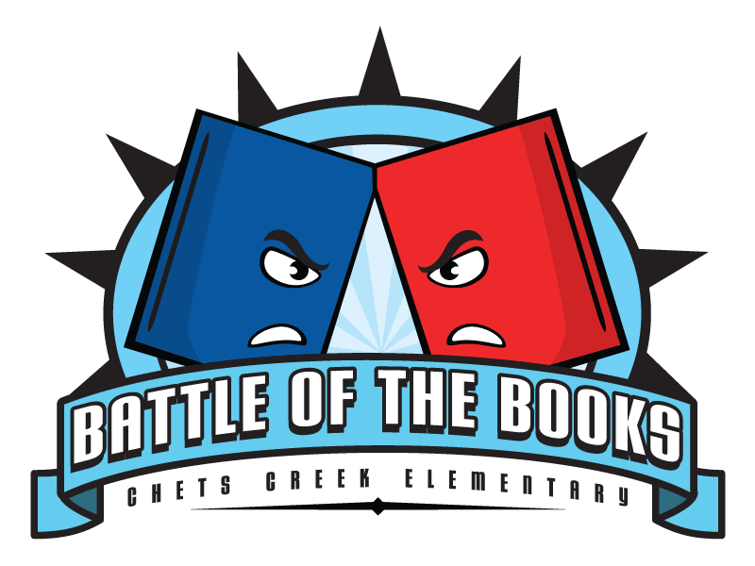
Battle of the Books
2016-2017

Do you love to read? Do you enjoy talking to other kids about a good book or interesting series? Do you love to read books that other kids your age have recommended? Do you enjoy competition? Do you enjoy discussing characters and plots? Then the Battle of the Books is for you! It’s that time of year again! The 2016-17 Marshall Elementary Battle of Books is ready to begin. This year there are 20 ICCA 2016-17 Award nominees. See the list below.
Marshall has a Web site dedicated to the ICCA Battle of the Books. The Web site will include the quizzes, book talks, permission slips and important dates for the ICCA Battle of Books. The Marshall Battle will take place on Friday, May 5th. We will need at least one team of five students to go to the District Battle of the Books on Friday, May 12th at 1:30 PM at Bryant Elementary. Please consider participating. For those students who choose to participate this year I will be providing guidance and book club meetings periodically throughout January, February, March, and April to assist with preparing you for the Marshall Battle. I will also provide a pizza party and prizes on the day of the Marshall Battle in May. I hope that all of you will consider participating!
To find out more about this year’s ICCA Book nominees and to view a book talk and a variety of book trailers go to this link:
http://dcsdbattlebooks.weebly.com/
If you think you are interested in participating in the 2016-2017 Battle of Books please fill out the information below and turn it in to Mrs. Stelzer or Mrs. Pfab by Monday, January 9th.
-----------------------------------------------------------------------------------------------------------------------------
Battle of Books Participation Form

Name____________________________________________
Homeroom________________________________________

